Kepler Data Release 9 Notes

KSCI-19049-001
Data Analysis Working Group (DAWG)
Jessie Christiansen (Editor)
Pavel Machalek (Editor)

Data Release 9 for Quarter Q6
Q.m |  | First Cadence MJD midTime | Last Cadence MJD midTime | First Cadence UT midTime | Last Cadence UT midTime | Num CINs | Start CIN | End CIN
6 | LC | 55371.9473 | 55461.7939 | 06/24/10 22:44 | 09/22/10 19:03 | 4397 | 21069 | 25466
6.1 | SC | 55371.9375 | 55399.0317 | 06/24/10 22:29 | 07/22/10 00:45 | 39779 | 620530 | 660309
6.2 | SC | 55399.8702 | 55430.7855 | 07/22/10 20:53 | 08/22/10 18:51 | 45389 | 661540 | 706929
6.3 | SC | 55431.6853 | 55461.8037 | 08/23/10 16:26 | 09/22/10 19:17 | 44219 | 708250 | 752469

Prepared by: _______________________________________ Date __________
Jessie Christiansen, Kepler Science Office, for the DAWG (next page)

Prepared by: _______________________________________ Date __________
Pavel Machalek, Kepler Science Office, for the DAWG (next page)

Approved by: _______________________________________ Date __________
Jeffrey Van Cleve, Editor-in-Chief

Approved by: _______________________________________ Date __________
Jon Jenkins, Co-I for Data Analysis & DAWG Lead

Approved by: _______________________________________ Date __________
Michael R. Haas, Science Office Director

Document Control
Ownership
This document is part of the Kepler Project Documentation that is controlled by the Kepler Project Office, NASA/Ames Research Center, Moffett Field, California.
Control Level
This document will be controlled under KPO @ Ames Configuration Management system. Changes to this document shall be controlled.
Physical Location
The physical location of this document will be in the KPO @ Ames Data Center.
Distribution Requests
To be placed on the distribution list for additional revisions of this document, please address your request to the Kepler Science Office:

Michael R. Haas
Kepler Science Office Director
MS 244-30
NASA Ames Research Center
Moffett Field, CA 94035-1000
Michael.R.Haas@nasa.gov

The Data Characteristics Handbook is the collective effort of the Data Analysis Working Group (DAWG), composed of Science Office (SO), Science Operations Center (SOC), Guest Observer Office (GO), and Science Team (ST) members as listed below:

Jon Jenkins*, Chair
Doug Caldwell*, Co-Chair
Allen, Christopher L.
Bryson, Stephen T.
Christiansen, Jessie L.
Clarke, Bruce D.
Cote, Miles T.
Fanelli, Michael N.
Gilliland*, Ron (STSci)
Girouard, Forrest
Haas, Michael R.
Hall, Jennifer
Ibrahim, Khadeejah
Kinemuchi, Karen
Klaus, Todd
Kolodziejczak, Jeff (MSFC)
Li, Jie
Machalek, Pavel
McCauliff, Sean D.
Middour, Christopher K.
Morris, Rob
Mullally, Fergal
Quintana, Elisa V.
Rowe, Jason
Seader, Shawn
Smith, Jeffrey Claiborne
Still, Martin
Tenenbaum, Peter G.
Thompson, Susan E.
Twicken, Joe
Uddin, Akm Kamal
Van Cleve, Jeffrey
Wohler, Bill

*Science Team

Table of Contents
Prefatory Admonition to Users 6
1. Introduction 7
1.1 Dates, Cadence numbers, and units 7
2. Release Description 8
3. Evaluation of Performance 9
3.1 Overall 9
4. Historical Events 11
4.1 Kepler mission timeline to date 11
4.2 Safe Mode 11
4.3 Loss of Fine Point 11
4.4 Attitude Tweaks 12
4.5 Variable FGS Guide Stars 12
4.6 Module 3 Failure 12
5. Ongoing Phenomena 13
5.1 Image Motion 13
5.2 Focus Drift and Jitter 14
5.3 Momentum Desaturation 14
5.4 Reaction Wheel Zero Crossings 16
5.5 Downlink Earth Point 16
5.6 Manually Excluded Cadences 16
5.7 Incomplete Apertures Give Flux and Feature Discontinuities at Quarter Boundaries 16
5.8 Argabrightening 17
5.9 Background Time Series 19
5.10 Pixel Sensitivity Dropouts 19
5.11 Short Cadence Requantization Gaps 19
5.12 Spurious Frequencies in SC Data 19
5.13 Anomaly Summary Table 20
6. Time and Time Stamps 22
7. Contents of Supplement 23
8. References 25

Prefatory Admonition to Users
The corrected light-curve product generated by the PDC (Pre-search Data Conditioning) pipeline module is designed to enable the Kepler planetary transit search. Although significant effort has been expended to preserve the natural variability of targets in the corrected light curves in order to enable astrophysical exploitation of the Kepler data, it is not possible to perfectly preserve general stellar variability on long timescales with amplitudes comparable to or smaller than the instrumental systematics, and PDC currently is known to remove or distort astrophysical features in a subset of the corrected light curves. In those cases where PDC fails, or where the requirements of an astrophysical investigation are in conflict with those for transit planet search, the investigator should use the ‘raw’ light-curve product, for which basic calibration has been performed but correction for instrumental systematics has not, instead of the PDC (‘corrected’) light-curve product. Where appropriate, the investigator can then use the ancillary engineering data and image motion time series provided in the relevant Data Release Notes Supplement/s for systematic error correction. Investigators are strongly encouraged to study the Data Characteristics Handbook and Data Release Notes for any data sets they intend to use. The Science Office advises against publication of results based on Kepler light curves without careful consideration and due diligence by the end user, and dialog with the Science Office or Guest Observer Office where appropriate.
Users are encouraged to notice and document artifacts, either in the raw or processed data, and report them to the Science Office at kepler-scienceoffice@lists.nasa.gov.

Users who neglect this Admonition risk seeing their works crumble into ruin before their time.

Introduction
These Data Release Notes provide information specific to the quarter of data currently being released. They have been drastically shortened relative to previous versions. The companion text has been moved to the Kepler Data Characterization Handbook (KSCI-19040). The section numbers and titles are identical in these Notes and that Handbook to assist the reader.

Dates, Cadence numbers, and units
Table 1: Contents of Release 9. CIN is the cadence interval number. All Release 9 cadence data were processed under KSOP-652 with SOC Pipeline 6.2, revision number r40414.
Q.m |  | First Cadence MJD midTime | Last Cadence MJD midTime | First Cadence UT midTime | Last Cadence UT midTime | Num CINs | Start CIN | End CIN
6 | LC | 55371.9473 | 55461.7939 | 06/24/10 22:44 | 09/22/10 19:03 | 4397 | 21069 | 25466
6.1 | SC | 55371.9375 | 55399.0317 | 06/24/10 22:29 | 07/22/10 00:45 | 39779 | 620530 | 660309
6.2 | SC | 55399.8702 | 55430.7855 | 07/22/10 20:53 | 08/22/10 18:51 | 45389 | 661540 | 706929
6.3 | SC | 55431.6853 | 55461.8037 | 08/23/10 16:26 | 09/22/10 19:17 | 44219 | 708250 | 752469

Release Description
No changes from the Data Characteristics Handbook.

Evaluation of Performance

Overall
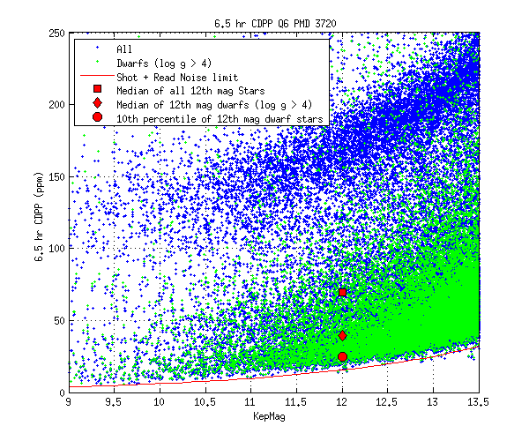
Figure 1: 6.5 hr Temporal Median (TM) of the Quarter 6 CDPP time series calculated by the TPS pipeline module for stars between 9th and 13.5th magnitude. The 6 hr TMCDPPs have been divided by sqrt(13/12) = 1.041 to approximate 6.5 hr TMCDPPs. Stars on the planetary target list with Kepler Magnitude < 13.5 and log g > 4, which are almost certainly dwarf stars, are shown as green +'s; other stars are marked with blue +'s.

Table 2: Aggregate Statistics for the TMCDPPs plotted in Figure 1: 6.5 hr Temporal Median (TM) of the Quarter 6 CDPP time series calculated by the TPS pipeline module for stars between 9th and 13.5th magnitude. The 6 hr TMCDPPs have been divided by sqrt(13/12) = 1.041 to approximate 6.5 hr TMCDPPs. Stars on the planetary target list with Kepler Magnitude < 13.5 and log g > 4, which are almost certainly dwarf stars, are shown as green +'s; other stars are marked with blue +'s.. Column Definitions: (1) Kepler Magnitude at center of bin. Bins are +/- 0.25 mag, for a bin of width 0.5 mag centered on this value. (2) Number of dwarfs (log g > 4) in bin. (3) 10th percentile TMCDPP for dwarfs in bin. (4) Median TMCDPP for dwarfs in bin. (5) Number of all stars in bin. (6) 10th percentile TMCDPP of all observed stars in bin. (7) Median TMCDPP for all stars in bin. (8) Simplified noise model CDPP.
Kepler mag at bin center | Number of dwarfs in bin | 10th percentile CDPP, dwarfs | Median CDPP, dwarfs | Number of all stars in bin | 10th percentile CDPP, all stars | Median CDPP, all stars | Lower envelope of model CDPP
9 | 31 | 9.8 | 37 | 180 | 13.2 | 89.5 | 3.8
10 | 160 | 12.1 | 34.6 | 567 | 14.7 | 100.3 | 6
11 | 607 | 18.5 | 33.8 | 1707 | 21.4 | 94.2 | 9.5
12 | 2169 | 24.9 | 39.2 | 4385 | 27 | 69.5 | 15.2
13 | 6767 | 36.4 | 50.9 | 10645 | 38.2 | 64.7 | 24.4

Historical Events
In this Section, we discuss cadences that may be lost to high-precision photometry due to planned or unplanned spacecraft events.

Kepler mission timeline to date
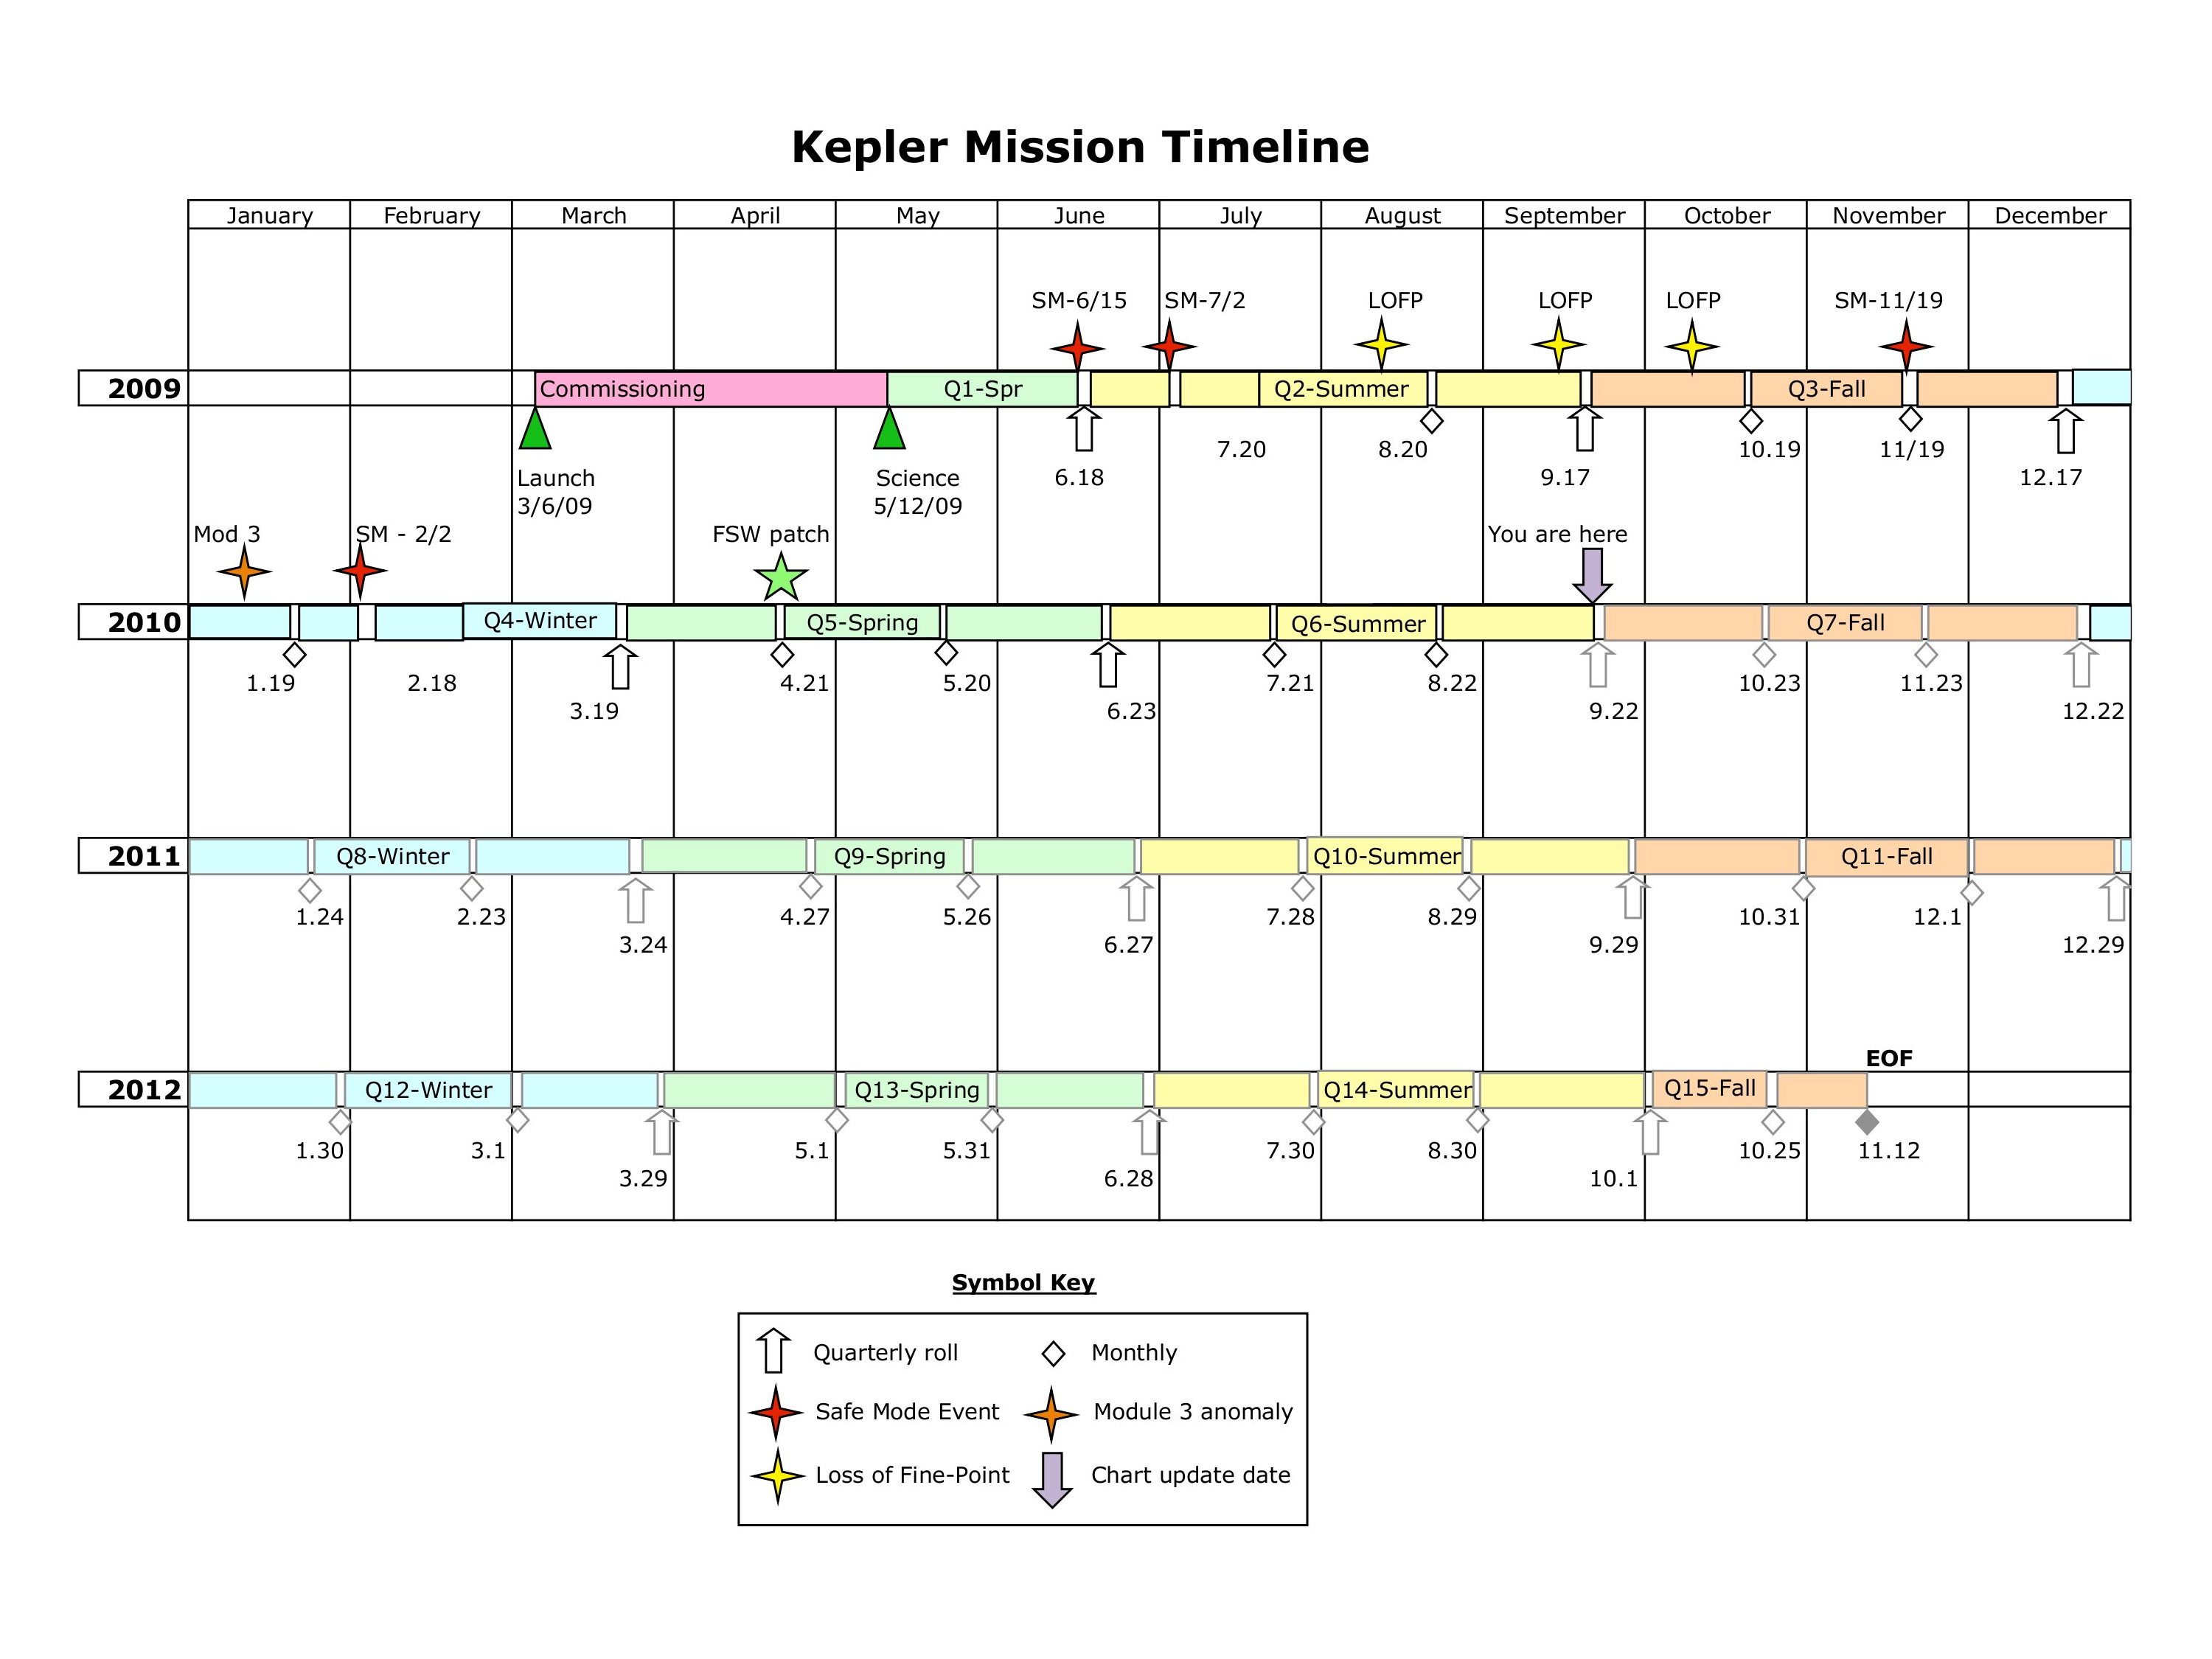
Figure 2: Kepler Mission Timeline as of end of Q6.

Safe Mode
No changes from the Data Characteristics Handbook.

Loss of Fine Point
No changes from the Data Characteristics Handbook.

Attitude Tweaks
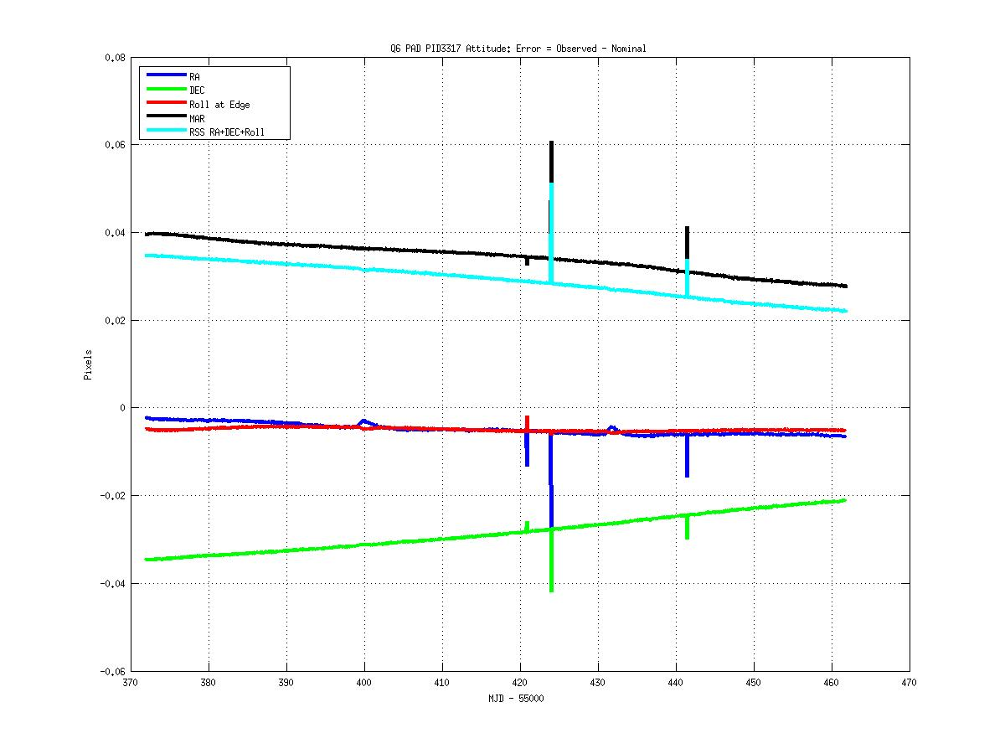
Figure 3: Attitude Error in Quarter 6, calculated by PAD using Long Cadence data.

Variable FGS Guide Stars
No changes from the Data Characteristics Handbook.

Module 3 Failure
No changes from the Data Characteristics Handbook.

Ongoing Phenomena

Image Motion
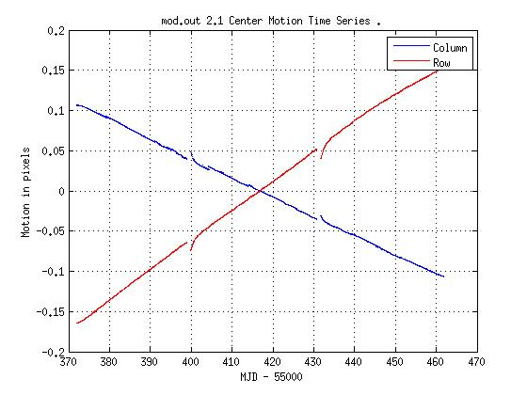
Figure 4: Mod out 2.1 Center motion time series. The gaps are monthly Earth contacts.

Focus Drift and Jitter
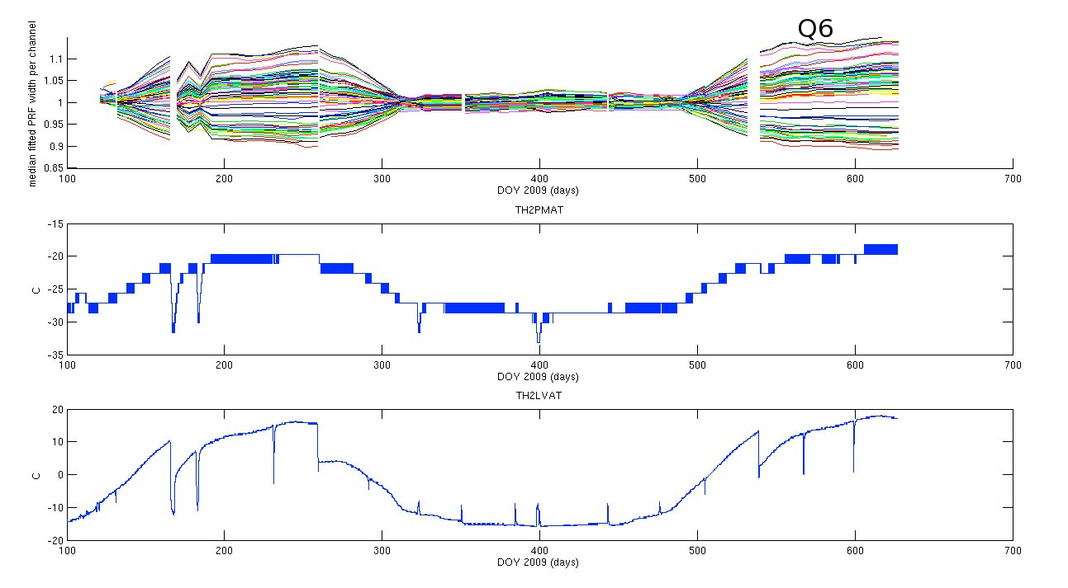

Figure 5: Correlation of variation in PRF width with various spacecraft temperatures, demonstrating the seasonal nature of focus and PRF changes.

Momentum Desaturation
Table 3: Momentum dumps in Q6 and the corresponding Long and Short Cadences. CIN = cadence interval number, RCI = relative cadence index.
LC
CIN RCI Date(MJD)
21150 82 55373.60245
21296 228 55376.58576
21442 374 55379.56906
21588 520 55382.55237
21734 666 55385.53567
21880 812 55388.51898
22026 958 55391.50229
22172 1104 55394.48559
22318 1250 55397.46890
22393 1325 55399.00142
22538 1470 55401.96429
22684 1616 55404.94760
22830 1762 55407.93090
22976 1908 55410.91421
23122 2054 55413.89752
23268 2200 55416.88082
23414 2346 55419.86413
23560 2492 55422.84743
23706 2638 55425.83074
23852 2784 55428.81405
23947 2879 55430.75524
24093 3025 55433.73852
24239 3171 55436.72183
24385 3317 55439.70514
24531 3463 55442.68844
24677 3609 55445.67175
24822 3754 55448.63462
24968 3900 55451.61793
25114 4046 55454.60123
25260 4192 55457.58454
25406 4338 55460.56784
25465 4397 55461.77343

SC
CIN RCI Date(MJD)
(Month 1)
622970 2441 55373.59938
622971 2442 55373.60007
627350 6821 55376.58269
627351 6822 55376.58337
631730 11201 55379.56600
631731 11202 55379.56668
636110 15581 55382.54930
636111 15582 55382.54998
640490 19961 55385.53261
640491 19962 55385.53329
644870 24341 55388.51592
644871 24342 55388.51660
649250 28721 55391.49922
653630 33101 55394.48253
658010 37481 55397.46583
660260 39731 55398.99835

(Month 2)
664610 3071 55401.96123
668990 7451 55404.94453
673370 11831 55407.92784
677750 16211 55410.91115
682130 20591 55413.89445
686510 24971 55416.87776
690890 29351 55419.86106
695270 33731 55422.84437
699650 38111 55425.82768
704030 42491 55428.81098
706880 45341 55430.75217

(Month 3)
711260 3011 55433.73546
715640 7391 55436.71876
720020 11771 55439.70207
720021 11772 55439.70275
724400 16151 55442.68538
728780 20531 55445.66868
733130 24881 55448.63156
733131 24882 55448.63224
737510 29261 55451.61486
737511 29262 55451.61554
741890 33641 55454.59817
741891 33642 55454.59885
746270 38021 55457.58147
746271 38022 55457.58215
750650 42401 55460.56478
750651 42402 55460.56546
752420 44171 55461.77036

Reaction Wheel Zero Crossings
Table 4: Zero crossing events in Q6, defined as the time from first to last zero crossing in the event, rounded to the nearest Cadence. The corresponding cadence numbers for SC are in the supplement.
Event# | MJD  Start | MJD  End | CIN  Start | CIN  End | RCI  Start | RCI  End | NumTLM  Samp
1 | 55379.569 | 55379.957 | 21442 | 21461 | 374 | 393 | 280
2 | 55382.552 | 55382.695 | 21588 | 21595 | 520 | 527 | 103
3 | 55388.499 | 55388.601 | 21879 | 21884 | 811 | 816 | 55
4 | 55397.469 | 55397.510 | 22318 | 22320 | 1250 | 1252 | 29
5 | 55410.894 | 55410.935 | 22975 | 22977 | 1907 | 1909 | 16

Downlink Earth Point
No changes from the Data Characteristics Handbook.

Manually Excluded Cadences
No changes from the Data Characteristics Handbook.

Incomplete Apertures Give Flux and Feature Discontinuities at Quarter Boundaries
No changes from the Data Characteristics Handbook.

Argabrightening
Table 5: Q6 LC Argabrightening Events with amplitude T_{MAD} > 10, and occurring on a number of channels T_{MCE} > 10. The columns are (1) CIN = Cadence Interval Number for Argabrightening cadences, (2) RCI = relative cadence index for Argabrightening cadences, (3) Date = Arg cadence mid-Times, MJD, (4) Mean Argabrightening statistic over Channels of Arg Event <S_{Arg}>_{FPA} (5) N_chan = Channels exceeding threshold in Arg cadence, (6) N_pipe = Channels exceeding default (pipeline) threshold in Arg cadence. MAD is calculated on a channel-by-channel basis.

CIN RCI Mid-Times(MJD) <S_{Arg}> N_chan N_pipe
21601 533 55382.81801 17.4 68 0
21724 656 55385.33134 7.2 18 0
21836 768 55387.61990 7.6 19 0
22014 946 55391.25708 8.5 26 0
22169 1101 55394.42429 8.2 23 0
22296 1228 55397.01936 7.8 21 0
23130 2062 55414.06099 8.3 27 0
23465 2397 55420.90624 62.4 69 13
23466 2398 55420.92668 15.4 27 1
23616 2548 55423.99172 100.0 80 36
23944 2876 55430.69394 4.9 11 0
23945 2877 55430.71437 7.4 18 0
23946 2878 55430.73481 10.5 30 0
23948 2880 55430.77567 18.9 59 0
24061 2993 55433.08465 14.0 56 0
24386 3318 55439.72557 7.8 16 0
24427 3359 55440.56335 36.9 79 0
24470 3402 55441.44199 66.3 80 13
24640 3572 55444.91570 6.8 22 0
24796 3728 55448.10335 3.3 13 0
24994 3926 55452.14920 7.4 12 0
25111 4043 55454.53993 10.0 34 0
25334 4266 55459.09662 18.2 67 0

Table 6: Q6 SC Argabrightening Events with amplitude T_{MAD} > 10, and occurring on a number of channels T_{MCE} > 10. The columns have the same meanings as Table 5: Q6 LC Argabrightening Events with amplitude T_{MAD} > 10, and occurring on a number of channels T_{MCE} > 10. The columns are (1) CIN = Cadence Interval Number for Argabrightening cadences, (2) RCI = relative cadence index for Argabrightening cadences, (3) Date = Arg cadence mid-Times, MJD, (4) Mean Argabrightening statistic over Channels of Arg Event <S_{Arg}>_{FPA} (5) N_chan = Channels exceeding threshold in Arg cadence, (6) N_pipe = Channels exceeding default (pipeline) threshold in Arg cadence. MAD is calculated on a channel-by-channel basis. Note consecutive detections of the largest events. A horizontal line separates the 3 Months of the Quarter. The relative cadence index (RCI) is reset at the start of each Month.

CIN RCI Mid-Times(MJD) <S_{Arg}> N_chan N_pipe
636501 15972 55382.81562 17.6 69 0
640187 19658 55385.32623 8.4 23 0
648880 28351 55391.24721 9.3 30 0
665777 4238 55402.75609 7.1 15 0

692439 30900 55420.91612 71.1 66 42
692440 30901 55420.91680 15.7 22 6
696948 35409 55423.98729 44.0 76 16
696949 35410 55423.98797 66.0 69 37

710291 2042 55433.07545 8.3 21 0
720044 11795 55439.71842 6.0 12 2
721281 13032 55440.56096 33.8 77 3
722571 14322 55441.43961 12.7 43 0
722572 14323 55441.44029 17.2 56 1
722573 14324 55441.44097 29.3 73 4
727678 19429 55444.91809 6.3 20 0
748502 40253 55459.10173 9.7 32 0

Background Time Series
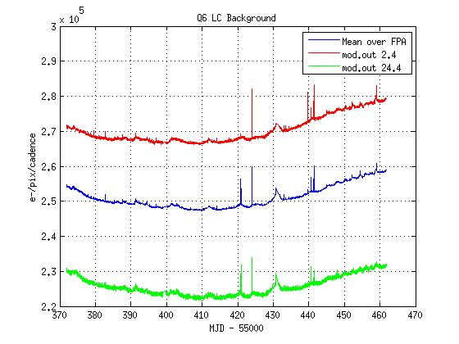

Figure 6: Background time series for Q6 showing the average over all the modules, and the modules furthest from (2.4) and nearest to (24.4) the Galactic plane. The narrow spikes are Argabrightening events.

Pixel Sensitivity Dropouts
No changes from the Data Characteristics Handbook.

Short Cadence Requantization Gaps
No changes from the Data Characteristics Handbook.

Spurious Frequencies in SC Data
No changes from the Data Characteristics Handbook.

Anomaly Summary Table
Machine readable CINs for the anomalies below are in the Data Supplement.
Table 7: Anomaly Summary Table for Long and Short Cadences
LC CIN
Start | End | Anomaly Type | Note
21069 | 21069 | EARTH_POINT | Monthly science data downlink
22395 | 22436 | EARTH_POINT | Monthly science data downlink
23949 | 23992 | EARTH_POINT | Monthly science data downlink
23465 | 23466 | ARGABRIGHTENING | See Section 5.8.
23616 | 23616 | ARGABRIGHTENING
24470 | 24470 | ARGABRIGHTENING

SC CIN
Start | End | Anomaly Type | Note
622969 | 622980 | COARSE POINT | See Section 5.3 for Momentum desaturations.
627349 | 627360 | COARSE POINT
631729 | 631740 | COARSE POINT
636109 | 636120 | COARSE POINT
640489 | 640500 | COARSE POINT
644869 | 644880 | COARSE POINT
649249 | 649260 | COARSE POINT
653629 | 653640 | COARSE POINT
658009 | 658020 | COARSE POINT
660259 | 660270 | COARSE POINT
664609 | 664620 | COARSE POINT
668989 | 669000 | COARSE POINT
673369 | 673380 | COARSE POINT
677749 | 677760 | COARSE POINT
682129 | 682140 | COARSE POINT
686509 | 686520 | COARSE POINT
690889 | 690900 | COARSE POINT
695269 | 695280 | COARSE POINT
696949 | 696949 | COARSE POINT
699649 | 699660 | COARSE POINT
704029 | 704040 | COARSE POINT
706879 | 706890 | COARSE POINT
692439 | 692440 | ARGABRIGHTENING | See Section 5.8
696948 | 696949 | ARGABRIGHTENING
711259 | 711270 | COARSE POINT | See Section 5.3 for Momentum desaturations.
715639 | 715650 | COARSE POINT
720019 | 720030 | COARSE POINT
724399 | 724410 | COARSE POINT
728779 | 728790 | COARSE POINT
733129 | 733140 | COARSE POINT
737509 | 737520 | COARSE POINT
741889 | 741900 | COARSE POINT
746269 | 746280 | COARSE POINT
750649 | 750660 | COARSE POINT
750970 | 751029 | COARSE POINT
752419 | 752430 | COARSE POINT

Time and Time Stamps
No changes from the Data Characteristics Handbook.

Contents of Supplement
The Supplement is available as a full package (DataReleaseNotes_09_SupplementFull.tar), which contains the files described below.

Pipeline Instance Detail Reports
Q6_LC_r6.2_ksop652_PA_+PDC_with_mpe_asrun_Pipeline_Instance_Detail_Report_110104.txt
Q6_SCM1_r6.2_ksop652_with_mpe_as-run_Pipeline_Instance_Detail_Report_110104.txt
Q6_SCM2_r6.2_ksop652_with_mpe_as-run_Pipeline_Instance_Detail_Report_110104.txt
Q6_SCM3_r6.2_ksop652_with_mpe_as-run_Pipeline_Instance_Detail_Report_110104.txt

Data Anomaly Types
DataAnomalyTypes_Q6_LC_PID3197_Summary.txt
DataAnomalyTypes_Q6M1_SC_PID3217_Summary.txt
DataAnomalyTypes_Q6M2_SC_PID3237_Summary.txt
DataAnomalyTypes_Q6M3_SC_PID3277_Summary.txt

Mod.out Central Motion
Q6_central_row_motion.txt
Q6_central_column_motion.txt

Average LDE board Temperature
Q6_LDE_averageBoardTemp.txt
Q6_TH12LVAT_MJD_gap.txt
Q6_TH1RW34T_MJD_gap.txt

Background Time Series
Q6_SCM1_background.txt
Q6_SCM2_background.txt
Q6_SCM3_background.txt
Q6_LC_background.txt

Flight System Events
Argabrightening Detections
ArgAgg_Q6_LC_PID3197_MADT010_MCT10_Summary.txt
ArgAgg_Q6M1_SC_PID3557_MADT010_MCT10_Summary.txt
ArgAgg_Q6M2_SC_PID3577_MADT010_MCT10_Summary.txt
ArgAgg_Q6M3_SC_PID3597_MADT010_MCT10_Summary.txt

Out of Fine Point Cadence Lists
Q6M1_SC_isNotFinePoint.txt
Q6M2_SC_isNotFinePoint.txt
Q6M3_SC_isNotFinePoint.txt
Q6_LC_isNotFinePoint.txt

Zero Crossing Events
Q6_Dec21_SC_ZeroCrossings.txt
Q6_Dec21_LC_ZeroCrossings.txt

Short Supplement Package
The Supplement also contains a short package suitable for emailing (DataReleaseNotes_09_SupplementSmall.tar). The small package does not contain the following files:
13Dec_SC_Q6M1_background.txt
13Dec_SC_Q6M2_background.txt
13Dec_SC_Q6M3_background.txt
Dec13_LC_Q6_background.txt

13Dec_Q6_LC_central_row_motion.txt
13Dec_Q6_LC_central_column_motion.txt
Q6_TH12LVAT_MJD_gap.txt
Q6_TH1RW34T_MJD_gap.txt

References
No changes from Data Characteristics Handbook.

